**Assignment 13 Practice Queries 2**

1. **Find the highest salary of each department**

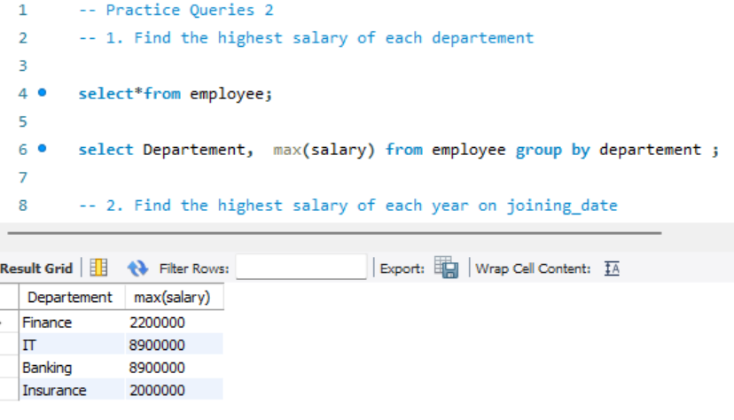

1. **Find the highest salary of each year on joining_date**

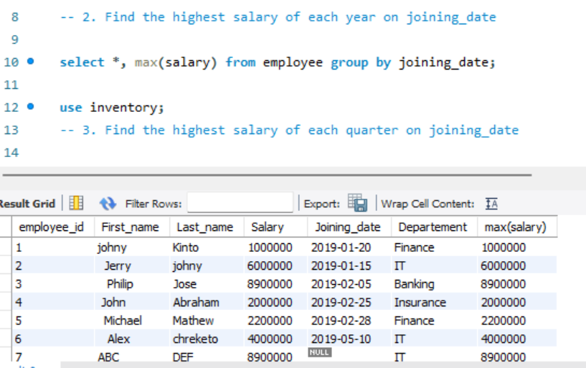

**3.Find the highest salary of each quarter on joining_date**

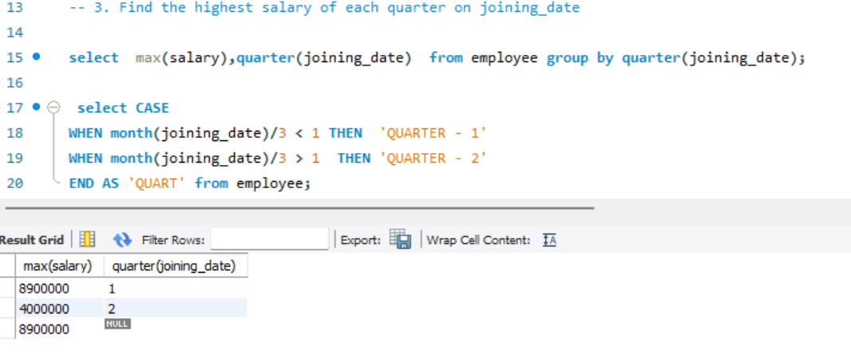**4. Find the highest salary of each week of the year on joining_date**

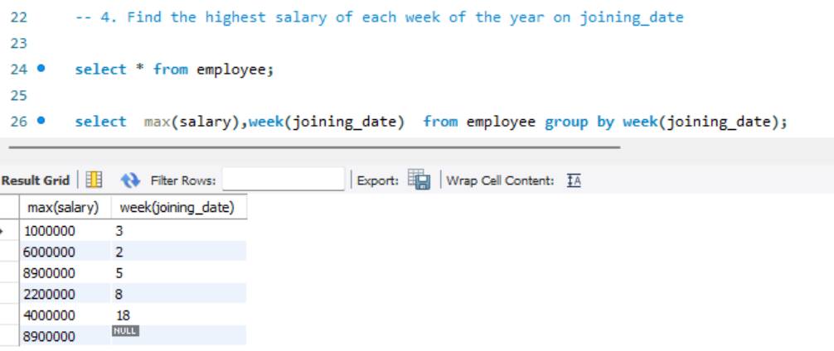

**5. Find the highest salary on the even days of joining_date**

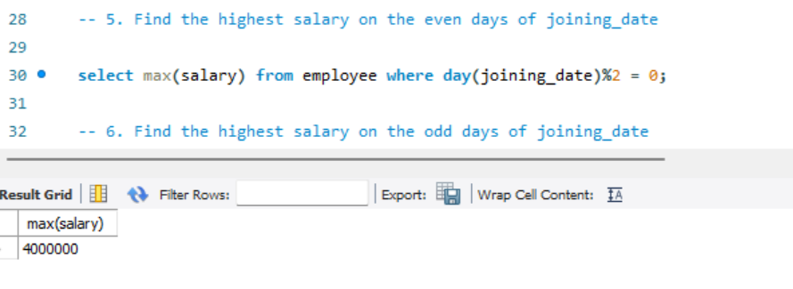

**6. Find the highest salary on the odd days of joining_date**

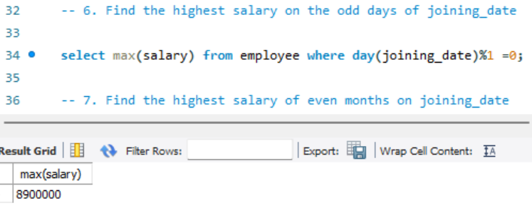

**7. Find the highest salary of even months on joining_date**

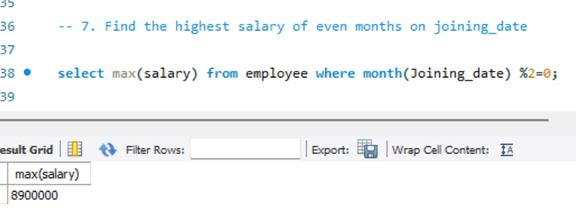

**8. Find the highest salary of odd weeks of the year on joining_date**

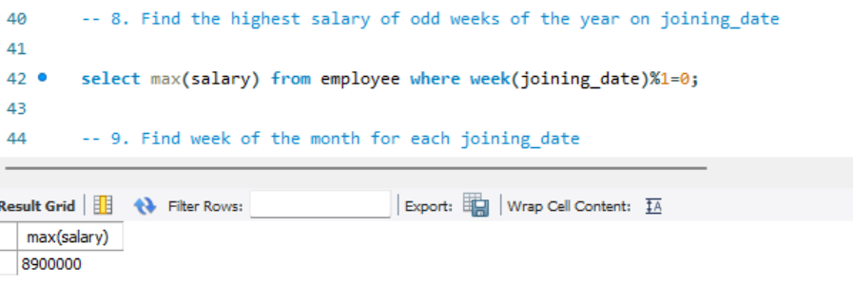

**9. Find week of the month for each joining_date**

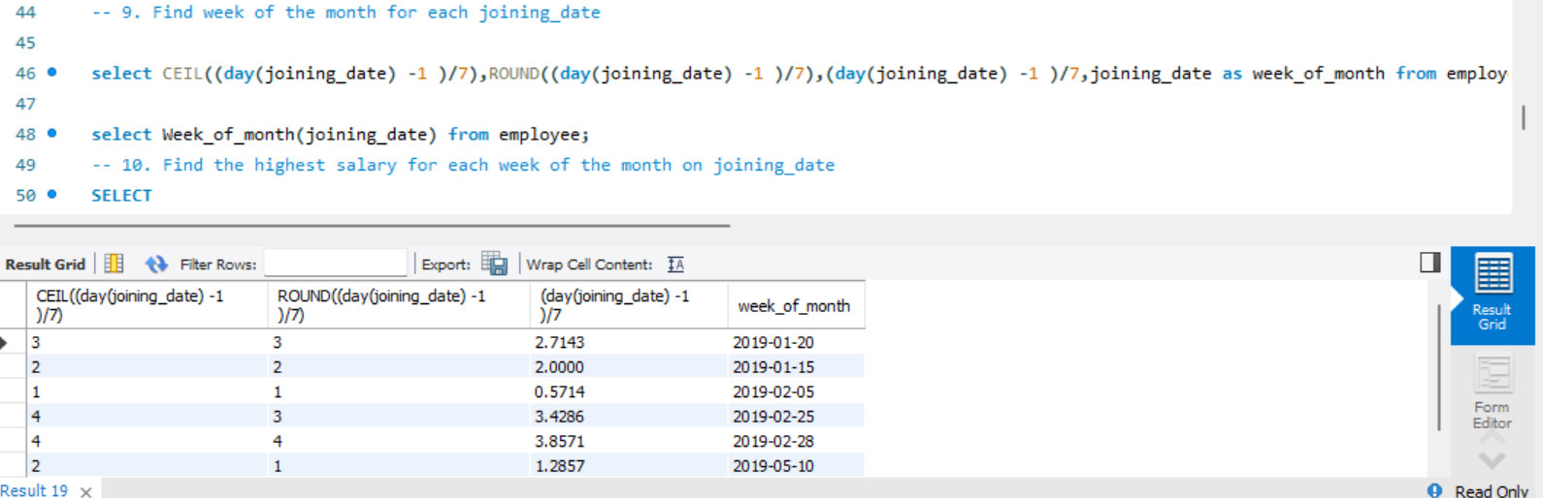

**10. Find the highest salary for each week of the month on joining_date**

